Providing you have information at hand that will be required to submit the transition notification form, the notification form is expected to take approximately five (5) minutes to submit for each kind of medical device.
Please submit one form for each “kind” of medical device you manufacture/supply.
The following guidance is designed to assist you with the form.

Page 1 – About the submitter
The first question asks about the details of the person submitting the form. This should be the name of the person submitting the form, even if they are submitting on behalf of an entity.
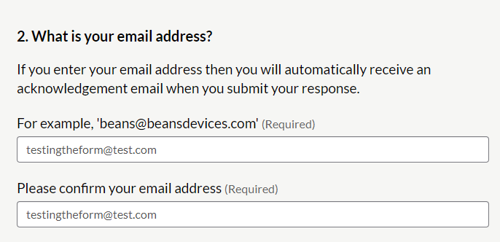
Your email address allows us to contact you to discuss the form you have submitted. If you would like this to be a generic email for the business you are submitting the request on behalf of, please use that address. This is also the email address where we will send you a copy of your notification for your records. It is important to let us know if your preferred contact email address changes.
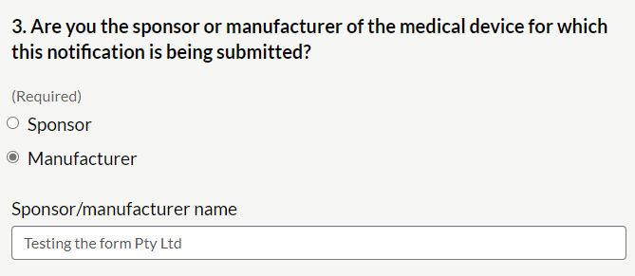
If you are importing medical devices that are made overseas, you will need to select ‘sponsor’.
If you are based in Australia and you are making the medical devices and then supplying them either to clients or a healthcare provider, you will need to select ‘manufacturer’. You will not have to submit the form a second time as the sponsor – if you are an Australian-based manufacturer, you are also the sponsor.

Page 2 – About the device
To fill in page 2 of the form, you will need information about the GMDN Term and Code for your device, as the first three fields relate to this information.
If, for example, you were submitting a notification for a retainer, you would need the following GMDN Code (numeric code), Term (description) and intended purpose:
GMDN 35310 Orthodontic appliance, retainer
A dental orthodontic appliances, fixed or removable, used to maintain teeth in corrected positions during the period of functional adaptation following corrective treatment. These appliances are also used to maintain the positions of the teeth and jaws effected by orthodontic procedures.
In the above example:
- The GMDN Code is 35310
- The GMDN Term name is Orthodontic appliance, retainer
- The GMDN Term is 35310 Orthodontic appliance, retainer
Note
You can access the full list of GMDN Terms and Codes by registering for an account on the GMDN Agency website. The GMDN Agency is a not-for-profit organisation responsible for creating and maintaining GMDN Terms and Codes. The GMDN Agency offers a basic plan that is free for all users. More information is available on the GMDN Agency’s registration page.

The fields in the form would be filled in as follows:
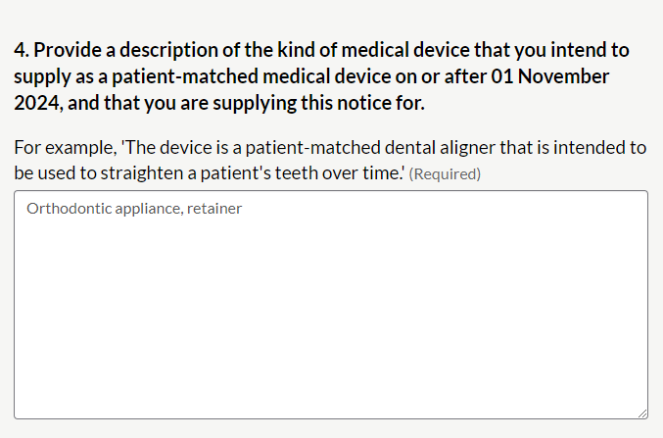
As you can see, the description of the medical device is taken from the GMDN Term being used in this example.
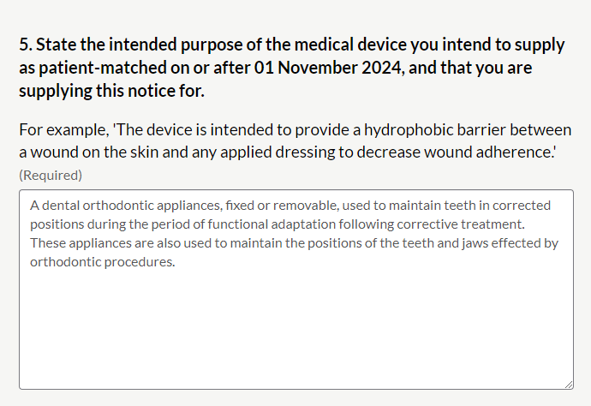
Again, the intended purpose is taken from the definition selected for the medical device in this example. There may be additional details that relate to your medical device that should be included here, for example if your product is only intended for use in patients with certain clinical indications.
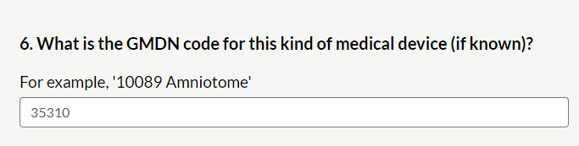
The GMDN code for the device is linked to the description and the intended purpose. Please note that even if your GMDN Code changes or is made obsolete after you have submitted your form, you will still be able to continue supplying your device until the end of the transition period. You may not, however, be able to submit an application for inclusion using this GMDN Code.
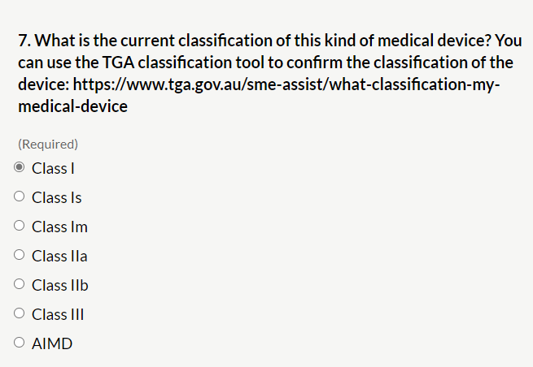
The classification of your medical device will depend on a number of factors including how long the device is intended to be used for and how invasive it is. You can check the classification of your medical device by using the online classification tool or by reading through the classification rules, which can be found in Schedule 2 of the Therapeutic Goods (Medical Devices) Regulations 2002.
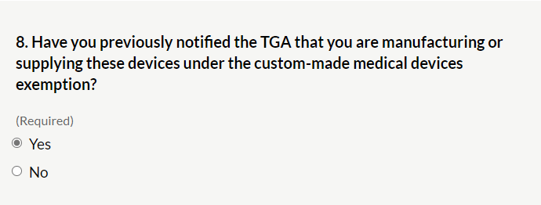
Submitting a custom-made medical device notification is an existing regulatory requirement that has been in place for a number of years. If you have not already submitted a notification, you should ensure you do so.
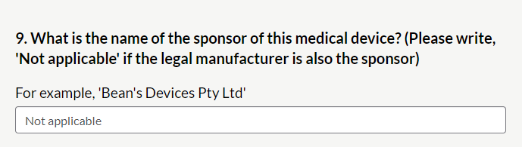
If you have previously indicated you are an Australian-based manufacturer of the medical device you need to enter ‘Not applicable’.
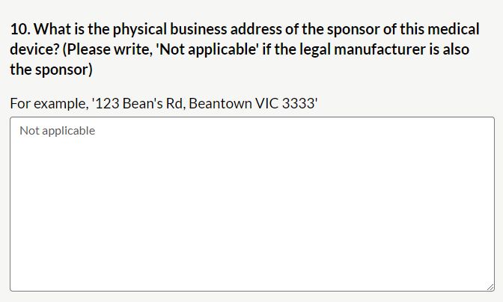
If you are the manufacturer, you can write “Not applicable”. Otherwise, please include your physical address, not a post office box, etc.
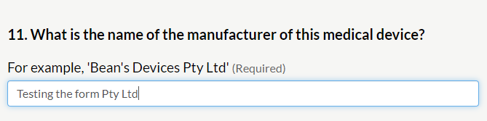
This should be the business name of the legal entity who is the manufacturer. This could be a person’s name if they are a sole trader, a partnership name, a corporation or other statutory body.
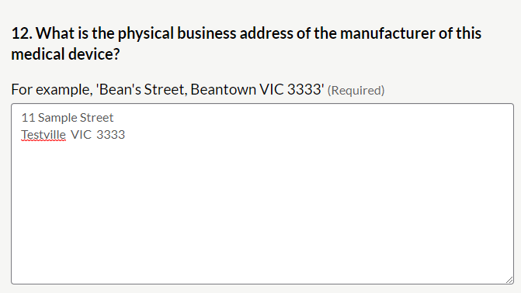

Page 3 - Declaration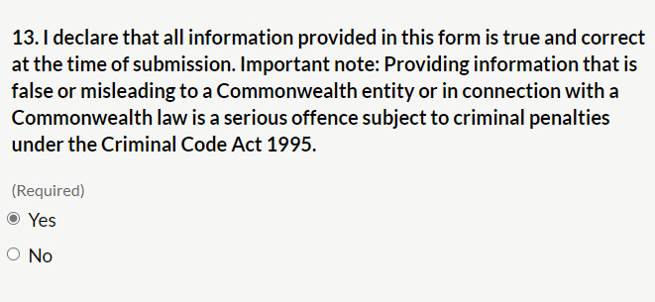
It is important that all information is true and correct. By selecting “yes” you are making a formal declaration under Australian law.

Page 4 – Almost done…
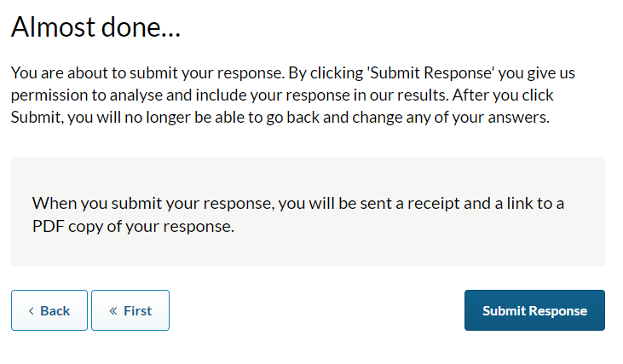
This is the final page before you submit your form. You are able to go back and amend any information using the “Back” buttons at the bottom of the form. Once you select “Submit Response” your information will be sent to the TGA.

After you have submitted your response
Once you have submitted your response, you will receive notification on your screen that will look like this:
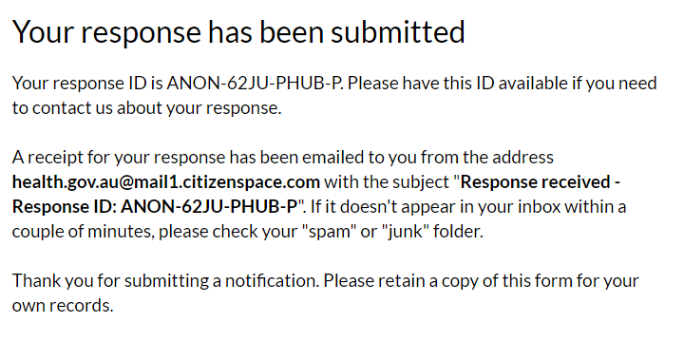
The email that you will receive will look like this:
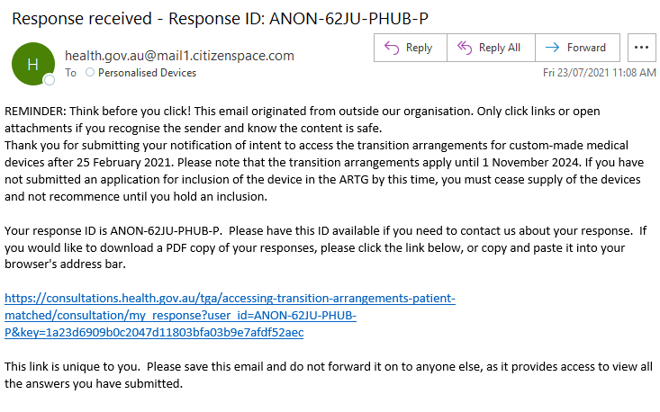
Following the link provided in this email will allow you to see what you have registered for transition.

Further information
Overview of the changes to the regulation of personalised medical devices: https://www.tga.gov.au/resource/personalised-medical-devices-including-3d-printed-devices
Frequently asked questions: https://www.tga.gov.au/regulatory-framework-personalised-medical-devices-frequently-asked-questions

